4.
I. State the name of the groups.
Group 1 – Female students of UMPSA.
Group 2 – Male students of UMPSA.
ii.
Male |  |  |  |  | Female
0.5 | 1 | 2 | 2 | 3 | 1 | 2 | 2 | 2 | 3
3 | 3 | 3 | 3 | 3 | 3 | 3 | 3.5 | 3.5 | 3.5
3 | 3.1 | 3.5 | 4 | 4 | 4 | 4 | 4 | 4 | 4
4 | 4 | 4 | 4 | 4 | 4 | 4 | 4 | 4 | 4
4.2 | 4.3 | 4.5 | 4.5 | 4.5 | 4 | 4 | 4.5 | 5 | 5
5 | 5 | 5 | 5 | 5 | 5 | 5 | 5 | 5 | 5
5 | 5 | 5 | 5 | 5 | 5 | 5.5 | 5.5 | 6 | 6
5 | 5 | 5 | 5 | 5 | 6 | 6 | 6 | 6 | 6.5
5 | 5.5 | 6 | 6 | 6 | 7 | 7 | 7 | 8 | 8
6.5 | 7 | 8 | 8 | 8 | 10 | 10 | 10 | 10.5 | 12

iii. Identify the method of data collection
Method of data collection : QUESTIONNAIRE AND SURVEYS
Google Form link: https://docs.google.com/forms/d/1j4ez_40oZnqHnBqoJQtoHdAcPIBEgXcWysbB1vzXJfg/prefill
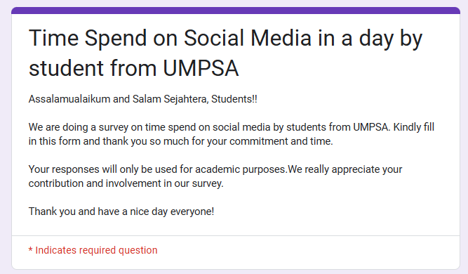
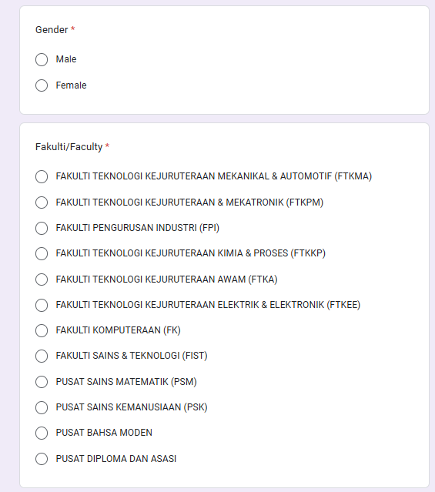
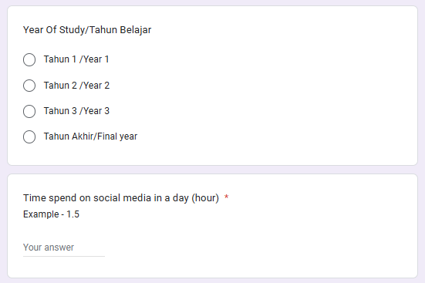

iv. State the sampling method you use to collect the data. Explain the sampling method process.
We used a non-probability sampling technique called Voluntary Sampling to obtain the data. In this approach, we distributed a Google Form link and spread it among all UMPSA students via social media platforms.
5.
Group Name | Measures of central tendency | Measures of variation
Male | Mean = 4.482 hour  Median = 4.75 hour  Mode = 5 hour  Midrange = 4.25 hour | Standard Deviation = 1.5654 hour  Variance = 2.4505  Range = 7.5 hour
Female | Mean = 5.24 hour  Median = 5 hour  Mode = 4 hour  Midrange = 6.5 hour | Standard Deviation = 2.3217 hour  Variance = 5.3902  Range = 11 hour

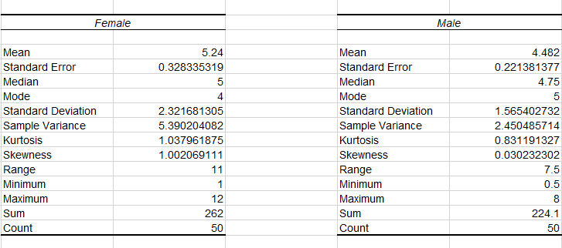
6.
1. Compare the Measure of Central Tendency
The mean for time spends on social media for female is higher than male which is 5.24 hours and 4.482 hours per day. Both groups have a different median value which is 5 hours for female students and 4.85 hours for male students. Based on the mode for both groups, the most of the female students spends on social media is 12 hours while the male students is 8 hours
2. Compare the Measure of Variation
The standard deviation of time spend on social media in a day for male and female students were different which is 1.5654 and 2.3217 respectively. Since, the standard deviation value for male students is smaller than female students, therefore the male students data are less dispersed and more consistent than female students data.

7.
Female |  | Male
Q1 | 4 | Q1 | 3.4
Median | 5 | Median | 4.75
Q3 | 6 | Q3 | 5
Min | 1 | Min | 0.5
Max | 12 | Max | 8
Mean | 5.24 | Mean | 4.482
IQR | 2 | IQR | 1.6
Lower Limit | 1 | Lower Limit | 1
Upper Limit | 9 | Upper Limit | 7.4

Shape:
Based on the location of the median, female students has a symmetric distribution while the male students has left-skewed distribution.
Average:
The average time for female students time spend on social media is higher than the male students. As we can conclude that female spend more than male.
Variability:
The IQR for female group is 2 hours which is wider than IQR for male which is 1.6 hours. This means the female has a greater variability in the time spend on the social media in a day. But as the male group has smaller IQR it indicates that the male data is more consistent than females for time spend on the social media in a day.
Range:
Without outlier, the time spend for social media in a day of female students have a range of 7 hours with minimum spend of 1 hour to 8 hours as compared to time spend for male students in social media have a range of 6 hours with a minimum spend of 1 hour to 7 hours.

